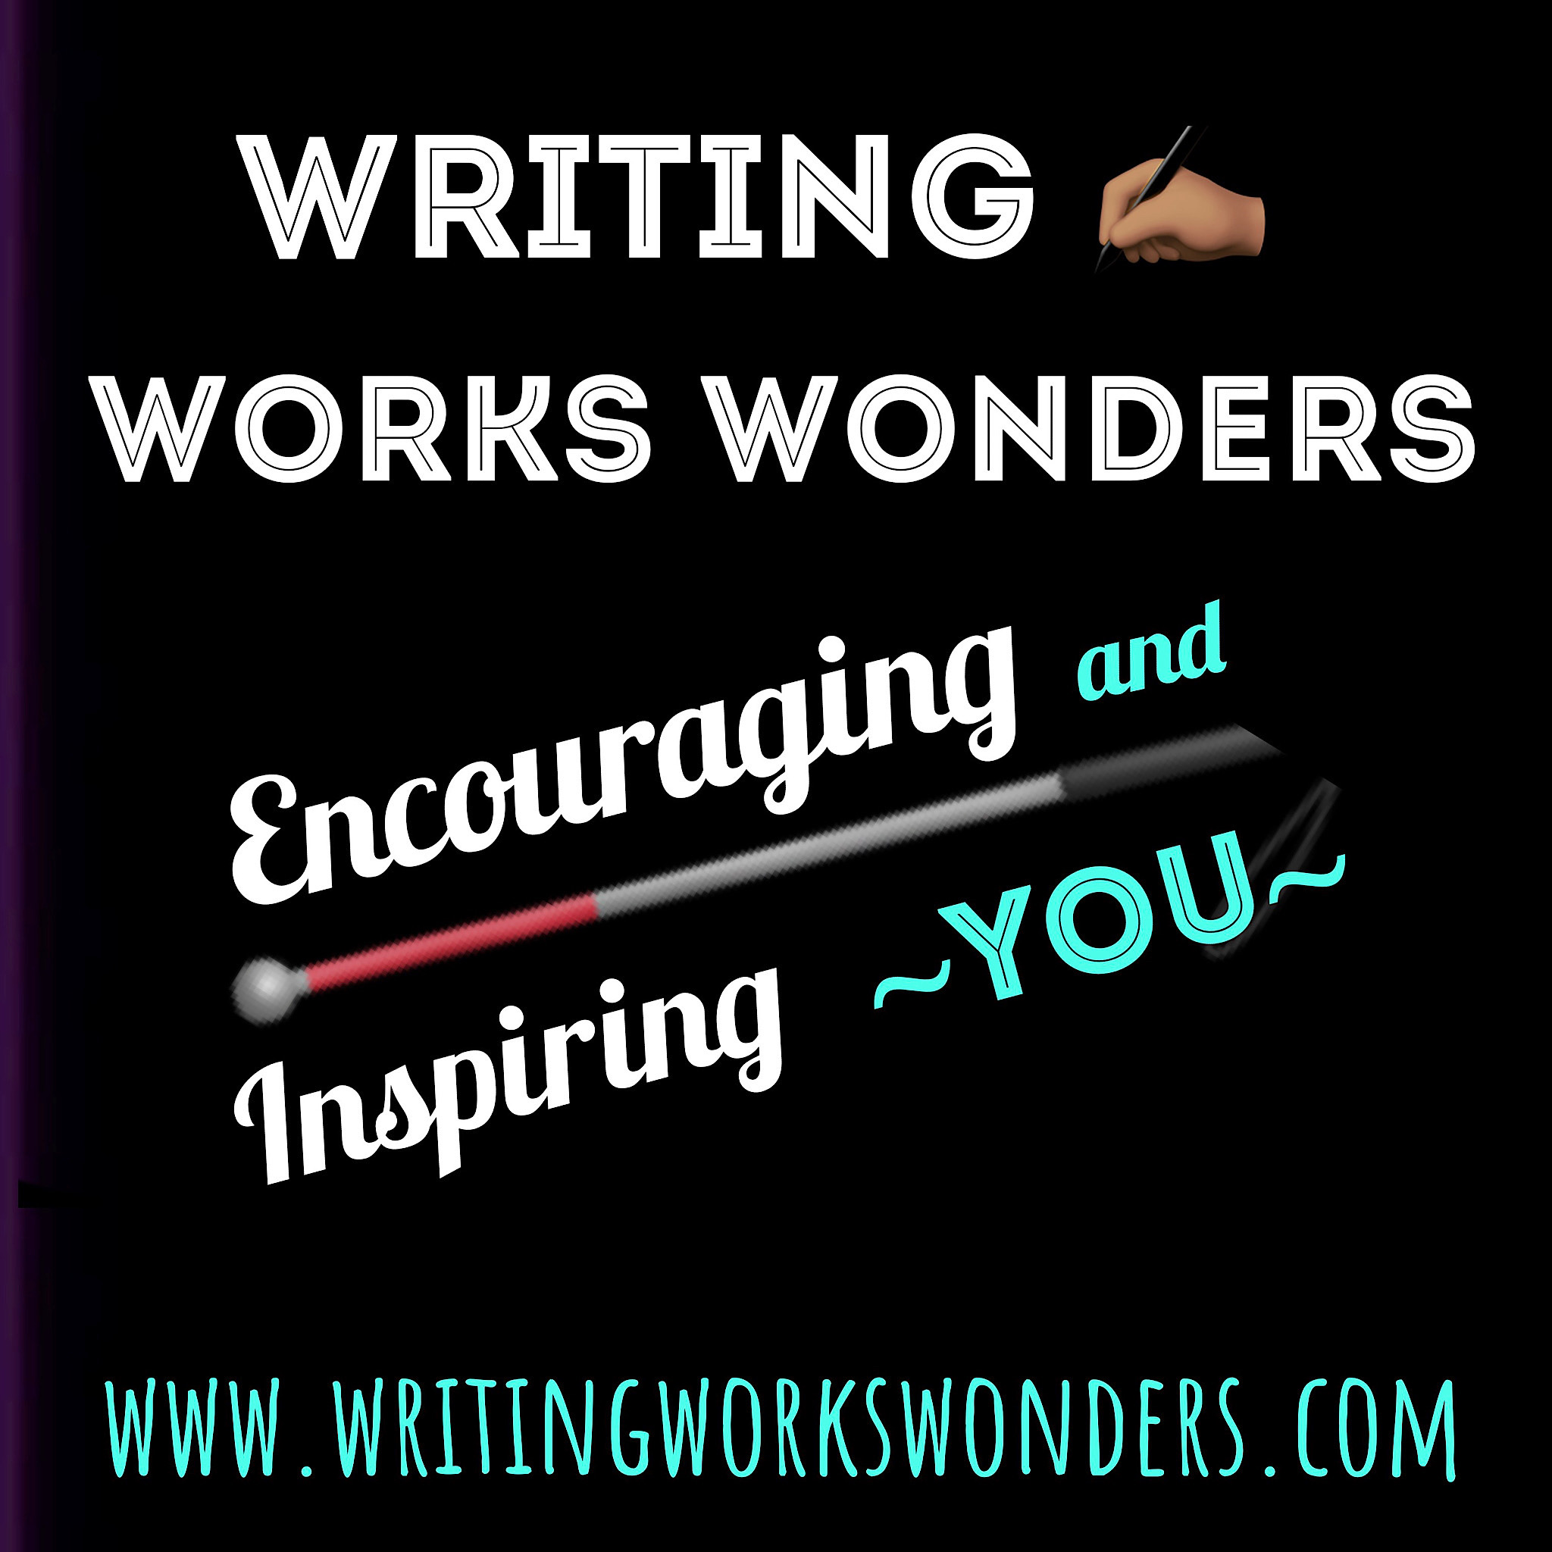
WRITING WORKS WONDERS
www.writingworkswonders.com

Listening to the Podcast and FAQ

- How do you listen to the podcasts (recordings) of Writing Works Wonders on your device?
- How can you automatically receive all the episodes and news related to Writing Works Wonders?

There are many easy options for listening to Writing Works Wonders. Listen on you smartphone, tablet, computer, Alexa, Google Home, or Victor Reader. Read on to discover how to access the show and also how a free subscriptions can ensure you never miss a minute!

All thatWriting Works Wonders goodness—- the fun author interviews, rich author-focussed discussions, workshops, Open Mic events, and “author clinics.” Oh yes, then there’s the bonus content that’s only on the podcast. Yes, that’s why you need to read on…

Take us with you to the gym, on vacation, commuting and more. Of course, you can sit back in your favorite chair and listen too!

Quick Intro- Listening via Apps & Alexa!
Click to the image listen to a brief explanation of listening on Alexa/Echo and our availability on podcast listening applications and websites.

Easy access to your podcast listening app!.
Please visit our website for all the podcast app icons. They are on this page
https://writingworkswonders.com/dont-miss-any-episodes-and-faq/

Just click your app’s icon for direct access to our podcast in their system.

Overview How to Listen to Our Show
For those less familiar with the options, here are some ideas. We provide more detail below.
- Website- Visit this website weekly for the latest episodes.
- Apps- Use a podcatching site or application to listen (i.e., Apple, Google, Amazon Music, Spotify, PocletCast, Overcast, etc.).
- ACB Media/Radio – Listen live on ACB’s Community Channel.
- More Devices!
  - Alexa – say, “Play the podcast Writing Works Wonders.”
  - Victor Reader Stream- click this link for instructions.
  - Google Home- ‘Hey Google, play Writing Works Wonders.”
  - Siri devices- ‘Hey Siri, play Writing Works Wonders.”

Free Subscriptions
To keep you up to date with the latest episodes, there are two types of free subscriptions.
- Email- Receive email notification of our free events- zoom, etc.
- Apps- Have our podcasts delivered to your podcast listening application as soon as they become available.

Email Sign-Up: Live Events- Zoom
WWW E-nail Alerts- Sign-up to receive e-mail notifications of our upcoming free Events and opportunities. We promise to respect your time, not to inundate your inbox, and never sell your information. You will always have the opportunity to unsubscribe at any time. If you have questions about the WWW Email-Alerts, contact us at WritingWorksPodcast@gmail.com Click hereto subscribe now.

App Subscription-
In Your Favorite Podcast App
Apple, Google, Amazon Music, Stutcher, Overcast… whichever podcast site or app you use, you can subscribe to our podcast for free. Why? So you never miss episodes, you receive BONUS content that is not always in our live shows, and you can listen to the best ones several times, whenever it suits you!

In you podcast listening application, search for Writing Works Wonders, and you will see an option to “subscribe.” Yes, this subscription to the Writing Works Wonders podcast is now, and will always be free.

When you click “subscribe” in your podcast program, the system will do the rest. From then on it will automatically retrieve the newest titles once they are ready. When you are ready to listen, click a new episode and it will play and download simultaneously.

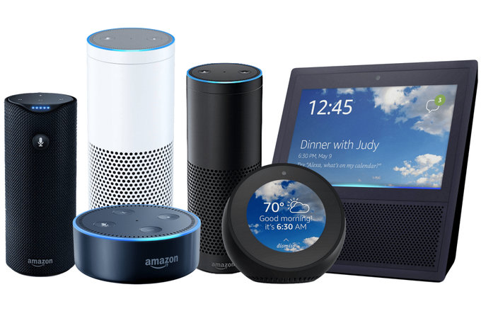
ALEXA & ECHO Listening Instructions

Tell Alexa or Echo, “Alexa, play the podcast Writing Works Wonders.”

- To mov forwarded or backwards among the episode numbers say, “Alexa, play the next/previous” episode.”
- You can also say, “Alexa, play the podcast Writing Works Wonders episode (insert the number).”

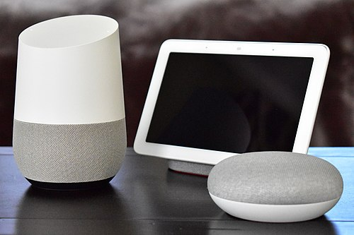
Google Home Instructions
Google Home and Google Nest speakers can also play podcasts. Simply use the following commands.
- “Hey Google, play Writing Works Wonders.”
- “Hey Google, listen to Writing Works Wonders.”
For more details visit this page at Google support.

Help, I Can’t Find the Podcast!
If you search for Writing Works Wonders in a podcast directory and do not find us, don’t despair. Just copy the RSSFEED link directly below and paste it into the program. That will allow you to listen and subscribe to all the Writing Works Wonders podcast goodness.
RSS Feed* for Writing Works Wonders
To subscribe to our podcast, copy this feed link and add it to your favorite podcast app or podcast listening website If you have any questions about how to listen, contact us for help.

Writing Works Wonders’ RSS feed link is
https://pinecast.com/feed/writing-works-wonders

*RSS feed stands for Real Simple Syndicated feed which is used to provide a direct link to podcasts and blogs in certain apps. It is a technical term.

