ISOLATION TO INSPIRATION

By
Writing Works Wonders

Website: www.WritingWorksWonders.com
Email: Writingworkspodcast@gmail.com
Co-hosts: Cheryl McNeil Fisher & Kathleen P. King

The story of two author-educators experiencing sight-loss, who find a common vision of-encouraging, inspiring, and accelerating writers’ sharing and development through a global platform for author interviews, virtual workshops, open mic events and more. Readers also enjoy the opportunity to interact with some of their favorite authors, such as Dr. Patrick Taylor, Jodi Thomas, Pamela Kelley and beloved narrator Kristin Allison.

Beginnings
Writing Works Wonders is the brainchild of Cheryl McNeill Fisher and was launched on ACB Community calls in September 2020.

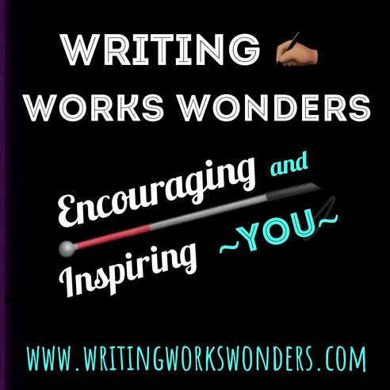
Cheryl is an accomplished author of children’s books and, recently, a biography/memoire. Cheryl has been a member of ACB, GDUI, and other vision impairment and writing associations for many years. One of her series communicate the experiences and resilience of people with visual impairments, through the words of Guide Dog Sammy. She has increasingly focused on encouraging emerging and experienced writers.

During the COVID-19 pandemic, when ACB Community began hosting Zoom calls on many different topics, Cheryl initiated a writing call. By 2021, she had been hoping and praying persistently for someone with whom she could work. Someone who would have the same vision, work ethic, but different skills to complement hers.

In Writing Works Wonders, the ACB Community call, Cheryl had cultivated a core group of talented writers, some of who were beginners and others quite advanced. These participants have been essential in the continuing development of this transformative endeavor. In addition, the ACB Community channel of ACB Media (fka ACB Radio) provided invaluable support in technical aspects, including streaming the interactive Zoom calls. The entire community, and world, has been adjusting to using virtual platforms to meet their social needs.
Advancing
In February of 2021, Dr. Kathy King suffered additional loss of sight and reached out to ACB through several community calls. When Kathy phoned into Writing Works Wonders virtual session, she met Cheryl and fellow authors. At that point, she knew that these people had similar goals, needs, and vision. Having published many books, led writing workshops and conferences worldwide, and recently retired from university professorship, she recognized an opportunity to use her expertise to continue to support writers.

Kathy and Cheryl began talking and emailing that week. Very shortly, including a test run and many discussions, Cheryl invited her to cohost the calls.

The vision of Writing Works Wonders has been refined, keeping the fundamental commitment constant: to encourage and support writers at all levels of experience with different abilities. This vision means both writers and readers benefit from the varied programming.

Reaching Further
Cheryl and Kathy implemented their vision and carefully, but quickly, fleshed out the scope and infrastructure of Writing Works Wonders. A high priority was to be able to repurpose their content and reach a larger audience.

Leveraging their many skills, these women have accomplished all of these goals on a very slim budget. To increase flexibility of their program, they purchased their own accounts for Zoom and podcast hosting. They started editing the Zoom recordings before posting on the public podcast. They also built a website to house and consolidate all of these essential components.

Together, they have worked hard to spread the word about the podcast and live Zoom calls through social media. Readers can follow Writing Works Wonders on Facebook, Twitter and Instagram. Next, Cheryl and Kathy are growing their group of followers and supports to spread the word of the podcast interviews, events and opportunities.

Cheryl and Kathy achieved so much in so little time because they developed a warm, comfortable partnership which is sustained by mutual respect and trust. They both understood that they needed to communicate frequently and freely with one another. Perhaps this point was one of the most important steps they took to build a strong, creative, effective, working relationship and friendship.

The website has much more than the fabulous show archive. Visitors will also find an abundance of resources, tips, and special content for writers. Cheryl and Kathy post short, Author Clinics, also referred to as Author Accelerators. The accelerators provide valuable productivity, writing, and marketing guidance for authors and publishers.

Listening
- LIVE on ACB New Media’s Community Channel, Friday 1pm Eastern. (Previously known as ACB Radio.)
- All podcast platforms.
- Tell Alexa/Echo, “Play Podcast Writing Works Wonders.”
- Visit www.writingworkswonders.com for the latest episodes.

© Cheryl McNeil Fisher and Kathleen P. King, 2021

